**Master’s Thesis**

Department of Ecology, Evolution, and Organismal Biology

College of Science and Math

Kennesaw State University

|  |  |
| --- | --- |
| Author: Zach Peagler | Supervisor: Mario Bretfeld, PhD |
| Email: [zpeagler@students.kennesaw.edu](mailto:zpeagler@students.kennesaw.edu) | **Email**: [mbretfel@kennesaw.edu](mailto:mbretfel@kennesaw.edu) |
| Phone: 770-893-8365 | **Phone**: 470-578-3275 |

**Committee:**

Dr. Christopher Cornelison, Kennesaw State University

Dr. Kyle Gabriel, Kennesaw State University

Dr. Matthew Weand, Kennesaw State University

**TITLE**

Optimization of biostimulant encapsulation and its efficacy on tomato

**ABSTRACT**

Finding sustainable ways to feed an ever-expanding population while reducing our reliance on synthetic fertilizers is of the utmost importance to humanity. To accomplish this, new sustainable agriculture techniques are required. One technique that has garnered attention is the use of plant growth promoting bacteria (PGPB) biostimulants. These microorganisms operate through various modes of action, the inoculation profile and load can be tailored to suit the target crop and inoculation method and have been shown to provide tangible benefits to the plant ranging from increased stress tolerance to reduced nutrient requirements. However, while commercial biofertilizers do currently exist, their widespread implementation has been hindered by inconsistent field results and a lack of economic feasibility stemming from sub-optimal carrier materials. One promising avenue is the use of an encapsulating carrier material, such as chitosan or alginate. These bio-polymers can form inoculated beads capable of delivering PGPB and arbuscular mycorrhizal fungi (AMF) that promote plant growth, stress tolerance, and produce shelf life. My research is aimed towards developing inoculated chitosan and alginate beads and testing their efficacy as biological fertilizers.

**Key words**: biostimulant, PGPB, AMF, chitosan, encapsulation, desiccation, tomato

**CONTENTS**

I. Background . . . . . . . . . . . . . . . . . . . . . . . . . . . . . . . . . . . . . . . . . . . . . . . . . . . . . . . . . . . . . . . . . . . . . . . . . . . 2

II. Hypotheses/Objectives . . . . . . . . . . . . . . . . . . . . . . . . . . . . . . . . . . . . . . . . . . . . . . . . . . . . . . . . . . . . . . . . . 5

III. Methodology . . . . . . . . . . . . . . . . . . . . . . . . . . . . . . . . . . . . . . . . . . . . . . . . . . . . . . . . . . . . . . . . 6

IV. Results . . . . . . . . . . . . . . . . . . . . . . . . . . . . . . . . . . . . . . . . . . . . . . . . . . . . . . . . . . . . . . . . . . . . 9

V. Timeline . . . . . . . . . . . . . . . . . . . . . . . . . . . . . . . . . . . . . . . . . . . . . . . . . . . . . . . . . . . . . . . . . . . . 10

VI. Budget . . . . . . . . . . . . . . . . . . . . . . . . . . . . . . . . . . . . . . . . . . . . . . . . . . . . . . . . . . . . . . . . . . . . . . . . . . . . . 11

VII. Integrative Aspects . . . . . . . . . . . . . . . . . . . . . . . . . . . . . . . . . . . . . . . . . . . . . . . . . . . . . . . . . . . . . . . . . . 12

VIII. Intellectual Merit . . . . . . . . . . . . . . . . . . . . . . . . . . . . . . . . . . . . . . . . . . . . . . . . . . . . . . . . . . . . . . . . . . . 12

IX. Broader Impacts . . . . . . . . . . . . . . . . . . . . . . . . . . . . . . . . . . . . . . . . . . . . . . . . . . . . . . . . . . . . . . . . . . . . . 13

X. References . . . . . . . . . . . . . . . . . . . . . . . . . . . . . . . . . . . . . . . . . . . . . . . . . . . . . . . . . . . . . . . . . . . . . . . . . . 13

XI. Figures . . . . . . . . . . . . . . . . . . . . . . . . . . . . . . . . . . . . . . . . . . . . . . . . . . . . . . . . . . . . . . . . . . . . . . . . . . . . . 18

1. **BACKGROUND**

The human population has recently surpassed 8 billion and is expected to exceed 9.8 billion by 2050 (UN, 2017), and this expanding population requires an expanding food supply, with food production projected to increase by 70% from 2005 to 2050 (Noel *et al.*, 2015). The current approach to maximizing crop yield is the use of synthetic fertilizers, chemically manufactured sources of nitrogen, phosphorous, and potassium, which have had environmental impacts including groundwater contamination, water body eutrophication, ecosystem disruption, greenhouse gas emission, and stratospheric ozone depletion (Conley *et al.,* 2009; Rosa & Gabrielli, 2022). These synthetic fertilizers are also expensive, accounting for 20% to 36% of a farm’s budget, with this cost nearly tripling in the past two years (Schnitkey *et al.,* 2021; Brownlie *et al.,* 2023). A recent report has stated that microbial fertilizers have the potential to generate billions in social benefits be reducing the emissions from synthetic fertilizers (UC Innovation Commission, 2023). Sustainable alternative solutions to synthetic fertilizers are necessary to alleviate the environmental and economic toll of synthetic fertilizers while also feeding an expanding human population (Fitter, 2012).

One possible solution is the use of biostimulants, which include microorganisms such as plant growth promoting bacteria (PGPB) and arbuscular mycorrhizal fungi (AMF) and biologically derived compounds (humic acid, biochar, kelp extract, etc.) that promote plant growth, improve crop quality and yield, and increase plant stress tolerance. Applications of microbial biostimulants have been found to reduce fertilizer requirements by 25% and increase crop yield by 17.9% on average (Adesemoye & Kloepper, 2009 ; Li *et al.,* 2022). While biostimulants show promise as a potential alternative for or amendment to synthetic fertilizers, microbial biostimulants are currently held back from widespread implementation due to logistical constraints arising from sub-optimal carrier materials. Carrier materials are necessary for inoculant production, as without a carrier most PGPB populations decline rapidly after inoculation (Bashan *et al.,* 2014).

Current carrier materials can be classified as either wet or dry, with dry inoculants (peat, clay, lignite, etc.) having longer shelf lives, lower contamination risk, and cheaper storage and transportation costs than liquid inoculants (Bashan *et al.,* 2014). Dry carriers can be applied directly to the soil or dissolved in water for a foliar inoculation, while wet carriers are applied almost exclusively as a foliar inoculation. Soil inoculation is more effective at increasing yield than foliar inoculation (Li *et al.,* 2022). Dry inoculants have shown inconsistent results in the field, shown unreliable performance in different environments, are often expensive, and are easily contaminated, preventing their implementation. To achieve the next step towards widespread biostimulant use, inoculation methods must prove that they can reliably maintain microbial viability and efficacy in the field after long-term storage and exposure to environmental stressors, all while being cheap, non-toxic, and simple to use (Bashan *et al.,* 2014).

A new inoculation method that has shown promise is encapsulation, the process of immobilizing biostimulants in droplet-derived beads which can then be dried for storage and transport. Encapsulation requires an encapsulation base, a protonation acid, a cross-linker (i.e., a dicarboxylic acid or other molecule with multiple negatively charged functional groups), and additives that can be introduced to help with maintaining microbial viability. One encapsulation base that has shown great promise is chitosan, itself biostimulant that has been shown to increase plant growth and stress tolerance in tomato and can entrap microbial biostimulants in beads (Chanratana *et al.,* 2019). Encapsulation has been shown to increase microbial viability in the presence of desiccation stress, as well as allow for a controlled release of the inoculant (Schoebitz *et al.,* 2013). Studies have shown that both bacteria and fungi can be encapsulated and maintain their viability, but many of these studies have been done with alginate rather than chitosan, despite chitosan having been shown to be more effective at maintaining microbial viability than alginate (Declerck, 1996; Bashan & Gonzalez, 1999; Chanratana *et al.,* 2018). Studies also suggest that encapsulation is necessary for PGPBs and AMFs to achieve maximum effectiveness and viability while also being practical for implementation by farmers (Bashan *et al.,* 2014; Berninger *et al.,* 2018).

Chitosan, as shown in **Figure 1** provided by Hao *et al.* (2017), is made up of repeating N-acetylated glucosamine units, generally 85% deacetylated. When combined with an acid, the deacetylated amine groups protonate, becoming NH3+. This allows the amine groups to act as binding sites for negatively charged functional groups, like those found on cross-linking agents. The acid used to protonate the chitosan, as well as the degree of protonation, have large impacts on the final bead formation and strength, and are likely to alter the microbial release rate (Fanaee & Filiaggi, 2023). Acetic acid is commonly used as a protonation agent throughout the literature (Chanratana *et al.,* 2018; Fanaee & Filiaggi, 2023). No tests have been done with organic acids besides acetic acid to protonate chitosan, and protonation with other organic acids (formic, propionic, butyric, etc.) may prove useful in altering bead morphology, water adsorption, and release characteristics. The degree of protonation affects the conformation the polymer takes, as shown in **Figure 2**, which will also likely affect bead characteristics (Dey *et al.,* 2016). This acid protonation also makes sterilization difficult, as the protonated chitosan cannot be autoclaved without undergoing chain fragmentation, as at elevated temperatures the chitosan is likely to undergo acid hydrolysis, as shown in **Figure 3.** This means that the production of chitosan-encapsulated inoculants will need to either find an order of operations that does not autoclave protonated chitosan or find an alternate method for the sterilization of the protonated chitosan solution. Finding an order of operations to not autoclave chitosan may prove challenging, as chitosan needs to be in an acidic solution to be soluble in water.

As for cross-linking agents, the inorganic sodium tripolyphosphate (TPP) has traditionally been successful in forming inoculated beads with chitosan, and is gentle and non-toxic, making it ideal for inoculant production (Chanratana *et al.,* 2019). The capture efficiency of some, but not all, bioactive compounds depend on the cross-linker's pH, and understanding under what conditions the cross-linker enables high efficiency biostimulant capture is of high importance to inoculant production (Ghanem & Skonberg, 2001). There could be environmental concerns about developing sustainable agriculture solutions that use TPP, an inorganic substance attributed to be partially responsible for water body eutrophication (Greenwood *et al.,* 1997). Due to their cross-linked nature with chitosan, it is unlikely that such solutions are susceptible to runoff in the manner traditional synthetic fertilizers are, but more testing is required to examine the runoff potential of encapsulated beads cross-linked with TPP. Should this be an issue, another option for cross-linking is the use of organic multi-carboxylic acids, such as glutaric, citric, or malonic acid.

Additives are a key component to increasing microbial viability when encapsulated and desiccated. Sugars, such as sucrose, glucose, and trehalose, can form biological glasses when desiccated which help prevent degradation of macromolecules in bacteria by replacing the hydrogen bonds on polar residues normally occupied by water, as well as physically immobilizing the macromolecules present in the cell, preventing protein aggregation, protein misfolding, and molecular crowding (Potts, 1994; Crowe *et al.,* 1998). Because of these properties, sugars are commonly used to increase desiccation tolerance (Strasser *et al*., 2009; Huang *et al.,* 2017). Antioxidants such as glutathione, ascorbic acid, and vitamin E help prevent oxidation and the ensuing reactive oxygen species (ROS) cell damage (Franca *et al.,* 2007) and would be worth experimenting with to understand how they interact with microbes in the encapsulation matrix following desiccation.

Desiccation is necessary for the successful commercialization of an encapsulation-based carrier material. Desiccation can increase the encapsulated microbial density, stop bacterial metabolism, and lower transportation and storage costs, but desiccation is also known to be one of the main causes of unviability in inoculants (Meng *et al.,* 2008; Berninger *et al.,* 2018). Microbes are not inherently tolerant to desiccation. Desiccation induces oxidative stress from ROS buildup and is known to damage membranes, proteins, and DNA of cells, with protein damage thought to be the leading cause of desiccation-induced cell death (Franca *et al.,* 2007; Tapia & Koshland, 2014). Previously, desiccation has been shown to induce protein aggregation, which subsequently induces molecular crowding, lipid peroxidation, ROS production, and leakage in the cell (Wang *et al.,* 2012; Bednarska *et al.,* 2013; Tapia & Koshland, 2014). In addition, the removal of water can cause protein misfolding and changes to the protein’s structure, which can lead to cell damage.

Despite multiple endogenous mechanisms for dealing with desiccation stress, and finding methods to increase desiccation tolerance in microbes is key to successful inoculant production (Greffe & Michiels, 2020). Air drying is a simple technique that involves exposing the inoculated beads to air at ambient pressure or under a vacuum (Santivarangkna *et al.,* 2007), and is highly effective at a low cost. There are many different approaches to air drying, ranging from simple airtight containers filled with a desiccant, such as silica gel, all the way to complex vacuum heated chambers with shaking plates (Berninger *et al*., 2018). The inoculant density heavily influences desiccation time, with more densely packed inoculants requiring longer drying times. Air drying also enables the microbes in the inoculant to produce endogenous responses to drought stress, increasing their viability.

In addition to questions associated with developments of inoculated beads, the timing at which the inoculants are introduced to the plant has been shown to greatly influence the inoculation efficiency, with some strains showing increased performance with seed inoculation, and others showing increased performance with soil inoculation (Ciccillo *et al.,* 2002; Afzal *et al.,* 2011). Biotic factors also influence inoculation efficiency, and can be inhibited by factors like microbiome priority effects and niche overlap (Verbruggen *et al.,* 2012).

Another route to sustainability is the use of low-water intensity farming, such as hydroponic farming. This approach reduces the potential for nutrient runoff and produces greater yields, however this often comes at the cost of crop quality (Stamatakis *et al,* 2003). Salt stress produces greater crop quality, often at the cost of yield by inducing blossom-end rot, which results in unmarketable fruit (Rosadi *et al.,* 2014). By combining these techniques with the application of biostimulants, it should be possible to offset the quality-quantity tradeoff, achieving a large yield of high quality fruit.

Multiple studies have shown that combinations of PGPBs are more effective than lone PGPBs (Madhaiyan *et al.,* 2009; ; He *et al.,* 2019). The exact biostimulant load depends on the target crop and soil conditions. To this end, multiple microbes will be considered for use in a final biostimulant consortium, with emphasis on those that have already been proven to provide benefits to tomato plants:

*Azospirillum brasilense -* PGPB that benefits the plant via nitrogen fixation, siderophore production, and by increasing lateral root growth (Sahoo *et al*, 2014; Li *et al*, 2005), and has been shown to increase plant stress tolerance (Casanovas *et al*, 2002). It has been shown to increase crop yield and plant nitrogen, phosphorous, and potassium content (Askary *et al*, 2009). It has also been reported to work well with *Methylobacterium oryzae* (Madhaiyan *et al*, 2009).

*Azotobacter chroococcum -* PGPB that operates via nitrogen fixation, phosphate solubilization, and vitamin, indole acetic acid (IAA), gibberellin (GA), hydrogen cyanide (HCN), siderophore, and cytokinin (CK) production (Abd El-Fattah *et al*, 2013; Revillas *et al*, 2000; Wani *et al*, 2007). Shown to increase germination rates and aboveground biomass and crop quality and yield in maize (Zahir et al, 2005).

*Bacillus subtilis -* PGPB that has been shown to improve fruit quality and yield in tomato (Mena-Violante & Olalde-Portugal, 2007; Kokalis-Burelle *et al*, 2002) and shown to increase metabolite production (Sharaf-Eldin *et al*, 2008). Shown to solubilize phosphate, fix nitrogen, produce IAA, CK, GA, HCN, and antibiotics, as well as exhibiting phytase activity (Ahmad *et al,* 2008; Arkhipova *et al,* 2005; Yao *et al,* 2006). It has been used as a biocontrol agent against aphids and pathogenic bacteria (Kokalis-Burelle *et al,* 2002).

*Methylobacterium oryzae -* PGPB that has been shown to improve fruit quality and yield in tomato in both foliar and chitosan encapsulated inoculations (Chanratana *et al.,* 2019). Operates through phytohormone (auxin and cytokinin) production, stress reduction via ACC deaminase production, increased nutrient availability through nitrogen fixation, and as a biopesticide (Chauhan *et al*., 2015).

*Pseudomonas putida -* PGPB that increases plant growth by solubilizing phosphate and producing IAA and siderophores (Hariprasad & Niranjana, 2009). Shown to inhibit ethylene production (Mayak *et al,* 1999). Shown to significantly increase tomato fruit macro- and micronutrient content (He *et al,* 2019). Shown to increase potassium, magnesium, and calcium uptake and decrease sodium uptake (Yao *et al,* 2010). Also shown to increase root and shoot growth (Glick *et al,* 1997; Hall *et al,* 1996).

In summary, microbial viability and efficacy following chitosan encapsulation-desiccation and subsequent storage hinge upon many factors such as encapsulation base, cross-linker, and dropwise addition conditions, as well as desiccation method, osmoprotectant addition, soil conditions, storage conditions, and more. There are many gaps in the literature surrounding chitosan encapsulation that need to be filled before chitosan can reasonably be considered for industrial commercialization. There have been no studies done on the release rate of desiccated chitosan beads formed with different protonation acids, and there have also been no studies done on the effectiveness of chitosan encapsulated-desiccated beads in maintaining microbial viability after extended storage. Addressing these will provide further insights into the potential for chitosan as a commercially viable biostimulant carrier.

1. **HYPOTHESES/ OBJECTIVES**

**Hypothesis 1 -** Combined soil and foliar *M. oryzae* application will increase salt stressed tomato fruit yield and fruit quality more than either soil or foliar inoculations.

Objective 1.1 - Determine the effect of *M. oryzae* inoculation methodon tomato plant growth and crop quality and yield.

**Hypothesis 2 –** Chitosan bacterial granules (CBGs) created under ideal conditions will more reliably provide plant benefits than CBGs made under non-ideal conditions.

Objective 2.1 - Optimize CBG creation method to enhance efficacy and viability.

Objective 2.2 - Successfully maintain CBG viability for 1 year after desiccation.

**Hypothesis 3 -** Inoculation of tomato with CBGs will increase plant growth and fluorometric parameters (e.g., chlorophyll fluorescence, efficiency of photosystem II) more than other biostimulant application methods.

Objective 3.1 - Determine the effect of biostimulant inoculation method (liquid, CBG, Pelleted CBG)

Objective 3.2 - Determine the effect of biostimulant inoculation timing (germination, transplantation)

**Hypothesis 4 –** Combined soil and foliar inoculation of microbial consortium will increase salt stressed tomato fruit yield and fruit quality compared to either soil or foliar inoculation.

Objective 4.1 - Determine the effect of microbial consortium inoculation method on tomato plant growth and crop quality and yield.

1. **METHODOLOGY**

**III.A. CBGs**

**III.A.1. CBG optimization**

Chitosan Bacterial Granules (CBGs) will be created by protonating 5% chitosan (85% deacetylated) with the necessary amount of an acid to achieve the desired degree of protonation. A solution of 5% TPP will be created, and both solutions will be sterilized. Microbes collected in the stationary phase will be added to 5% protonated chitosan aliquots in concentrations that will facilitate the desired concentration after dilution. This microbial consortium and chitosan mixture can then be added to the TPP via dropwise addition using a peristaltic pump. After curing for 24 hours, the beads will be transferred to a vacuum desiccation chamber and allowed to dry until no water remains (approximately 24 hours). Pelleted CBGs will be created through chitosan microencapsulation followed by seed adhesion via pelleting, as described by Pedrini *et al. (*2018).

Tests will be performed on chitosan protonation acid, chitosan protonation degree, dropwise addition nozzle size, cure time, desiccation method, and desiccation time to identify the optimal conditions for CBG creation. We will also be assessing the entrapment efficiency of bioactive compounds and microbes in CBGs, as well as the subsequent release rate under various conditions. Steps will be taken to increase the microbial viability of the CBGs as needed, starting with the addition of osmoprotectants (sucrose, vitamin C, salicylic acid). To facilitate successful microbial colonization upon rehydration, nutrients will be added to CBGs, paying special regard to Fe and Mo alongside other nutrients required by N-fixers but not provided by root exudates.

For each new iteration of CBG and at set points in the creation process (freshly cured, 24H desiccation increments until completely dry, rehydration), the author will collect images and use them to approximate surface area and will also collect weight, volume, encapsulation efficiency, and release rate. Weight will be collected on a lab scale. Volume will be assessed by placing 10 CBGs in a 1mL graduated cylinder filled halfway with DI water. Encapsulation efficiency will be calculated by measuring the microbial concentration of (1) the microbial-chitosan solution prior to dropwise addition and (2) the cross-linking solution following dropwise addition. Release rate will be assessed by measuring the microbial concentration of the rehydration solution at set intervals after introduction of the desiccated CBGs.

**III.A.2. CBG longevity trial**

CBGs with seven different inoculations (five treatments comprising single bacteria inoculation of each species mentioned above, one treatment containing every bacteria, and one control treatment without bacteria) will be stored to assess their viability over time. Each sample will contain 50g of CBGs and storage conditions include temperature (-20, 4, 24°C) and atmosphere exposure (sealed and open). At set intervals (1 week, 1 month, 3 months, 6 months, 1 year) the microbial viability will be quantified via plate counting and the effect on seed germination will be examined by placing the CBG on a petri dish containing limited nutrient solution and a tomato seed.

**III.B. Greenhouse trials**

**III.B.1. Tomato inoculant trial 2023**

This trial will be performed to assess the effect offoliar, soil, and joint inoculation of *M. oryzae* on salt stressed tomato plant health and crop quality and yield. This trial will take place in the hydroponic greenhouse at the KSU field station: 32 tomato plants across four rows with eight plants per row. Row A is the control, with no treatments applied. Row B is subjected to soil inoculation with CBGs. Row C is subjected to foliar inoculation with a spray outside the greenhouse. Row D is subjected to both soil and foliar treatments. The unit of replication for bacterial treatments are the tomato plants. The unit of replication for sugar and weight measurements are individual tomatoes.

Plants will be inoculated at the time of transplantation. Nutrients and salt stress will be continuously applied via nutrient solution. Tomato plants will be allowed to grow for 7 months before teardown, with tomato fruits harvested as they ripen. Initial fruit data will be collected at the time of fruit harvesting. Fruit will be weighed, assessed for blossom-end rot, and catalogued with row, pot, and cluster information. Weight measurements will be performed, and blossom-end rot will be assessed by visual observation of the fruit. Authors will use a Li-COR Li-600 and PhotosynQ MultispeQ V2 to measure plant fluorometric parameters. Sugar concentration will be measured with a Fisherbrand Brix. Firmness will be measured with a penetrometer.

The statistical power of this experiment is low, at 0.39 for an effect size of 0.4 with 4 groups, 8 replicates per group, and 0.05 significance level. However, this is the greatest number of tomato plants possible in the space available at the time.

**III.B.2. Tomato inoculant trial 2024**

The space available for the 2024 tomato inoculant trial is greater than that available for the 2023 trial, allowing for more groups or more replicates per group. The plan is to use optimized microbial composition in optimized CBG formulation alongside traditional foliar inoculation. Soil inoculant profile vs foliar inoculant profile. Treatments: control, saline, CBGs, CBGs saline, foliar, foliar saline, CBG + foliar, CBG + foliar saline, for a total of 8 groups. At 8 replicates per group, that is a power of 0.56 for an effect size of 0.4. Ideally, we could use 12 replicates per group and achieve a power of 0.80, but we are limited by space in the KSU hydroponic facility. The same measurements taken for the 2023 trial will be taken again in 2024, but this time will include ethylene headspace measurements, tomato quality assessments, and bacterial community analysis.

To obtain ethylene headspace measurements, authors will tape a plastic bag and a valve with lengths of tubing on each outlet over a ripening tomato fruit, and seal the opening with Teflon tape, leaving the valve outside the plastic bag and one length of tubing inside the bag. Authors will then inflate the plastic bag with an electric air pump and seal the valve. After allowing the sample to sit for 60 minutes, 100 mL of the air inside the plastic bag will be collected with a gas-tight syringe and placed in a headspace vial. Following collection, samples will be processed for ethylene content on the GC-MS within 24 hours.

Tomato quality assessments will be performed by Warren Analytical Laboratories (https://warrenlab.com). Authors will submit 60 tomato samples for quality assessment, with all samples harvested at the same time and the same number of samples from each treatment.

For bacterial community analysis, authors will take 48 total samples: 24 day one samples and 24 end of trial samples. Samples will be processed within 24 hours of collection, following the instructions on the DNEasy PowerSoil Pro kit and stored in a freezer at -4° C. Authors will then send processed DNA samples to LC sciences for 16S microbial community analysis.

**III.B.3. Direct inoculation trial**

This experiment will involve cultivating 144 tomato plants (cultivar BHN 589) for 40 days in the greenhouse outside of the KSU Science building. A graphical abstract of this experiment can be seen in **Figure 4.** There will be 12 treatments (control, liquid at germination, liquid at transplantation, liquid at both stages, CBG at germination, CBG at transplantation, CBG at both stages, Pelleted CBG at germination, Pelleted CBG at germination with CBG at transplantation, and Pelleted CBG with liquid at transplantation) with 12 replicates per group. The inoculation is slated to include the entire microbial consortium listed above at 1x106 CFU/g each. Power analysis on this reveals a power of 0.90 for an effect size of 0.4, a significance of 0.05, 12 groups, and 12 replicates per group.

**III.C. Statistical analysis**

All statistical analysis will be done in the latest version of R, currently 4.3.2. Linear mixed models will be used to analyze plant growth and environmental data, and ANOVAs will be used to examine differences between treatments. Fruit quality and microbial community metrics will be assessed with principle component analysis.

1. **RESULTS**

**IV.A. CBG optimization**

Authors have had success in creating inoculated CBGs and in qualifying that microbial viability can be maintained after desiccation via air-drying. Quantitative measurements for microbial viability have not yet been conducted. Preliminary results from nozzle tests show that smaller nozzle sizes produce beads with the least reagent waste. It also revealed microplastics in the CBGs. Plastic nozzles are a no-go, and future CBG creation should be done without plastic (especially 3D printed) parts contacting the granules. Preliminary results have shown that bead morphology can vary drastically even within a single batch made under identical conditions, as shown in **Figure 5**. Preliminary results for CBG desiccation show that desiccation reduces CBG weight by 90%, as shown in **Figure 6.**

**IV.B. Tomato Inoculant Trial 2023**

Stomatal conductance is graphed in **Figure 7**, and all treatments were found to be significantly different from the control using an lmer test when modeled with stomatal conductance as a response, treatment as a predictor, and relative humidity as a random effect.

Fruit weight across treatments is graphed in **Figure 8**, and foliar and joint treatments were found to be significantly different from the control using an lmer test when modeled with fruit weight as a response and treatment as a predictor. Total yield across treatments by blossom-end rot presence is graphed in **Figure 9*,*** and the joint inoculation was found to have a significantly higher portion of fruit with blossom-end rot than the control treatment using an lmer test when modeled with total yield as a response and treatment as a predictor.

Fruit sugar concentration across treatments is graphed in **Figure 10**, and foliar and joint inoculations were found to have significantly higher average sugar concentrations using an lmer test when modeled with sugar as a response and treatment as a predictor. However, when the sugar content is calculated as an absolute weight value rather than a relative percentage as graphed in **Figure 11**, the sugar content in the foliar and joint inoculation treatments is significantly less than the control, found using an lmer test and modeled with the sugar content as a response and treatment as a predictor.

1. **TIMELINE**

|  |  |  |
| --- | --- | --- |
| **Semester** | **Experiments** | **Objectives** |
| Spring 2023 | 1. Initial CBG experimentation 2. Tomato inoculant trial 2023 | 1. Successfully create inoculated CBGs 2. Determine effect of *M. oryzae* inoculation methodon tomato plant growth and crop quality and yield |
| Fall 2023 | 1. CBG optimization 2. CBG longevity start | 1. Optimize CBG creation method to enhance efficacy and viability 2. Successfully maintain CBG viability after desiccation |
| Spring 2024 | 1. Bacterial compatibility assays 2. Direct inoculation trial | 1. Determine the effect of biostimulant inoculation method on tomato plant growth and fluorometric parameters 2. Determine the effect of biostimulant inoculation timing on tomato plant growth and fluorometric parameters |
| Fall 2024 | 1. Tomato inoculant trial 2024 2. CBG longevity cont’d | 1. Determine effect of biostimulant consortium application method on tomato plant growth and crop quality and yield 2. Successfully maintain CBG viability after 1 year of desiccation |

1. **BUDGET**

|  |  |
| --- | --- |
| **Item** | **Price** |
| **GENERAL LAB SUPPLIES** |  |
| Corning Polystyrene Sterile Serological Pipets, 25 x 0.2mL, Pack of 25 | $86.00 |
| Kimwipes Cleaning Tissue, 4.5" x 8.5" | $22.00 |
| Potassium Chloride, Crystal, Laboratory grade, 100g | $6.80 |
| Polystyrene Petri Dishes, Sterile, 100 x 15 mm, Case of 500 | $136.80 |
| Sterile Transfer Pipets, pack of 100 | $42.00 |
| Ultra-Cruz Anti-Static Weigh Boats, Medium, pack of 500 | $65.95 |
| Trehalose Anhydrous, 100g | $250.00 |
| Sodium tripolyphosphate, CAS 7758-29-4, 500g | $33.00 |
| alpha-Tocopherol, 95%, 100g | $97.00 |
| L-Ascorbic Acid, Powder, 100g | $17.25 |
| Hydrochloric Acid, 12.1 M Glass Bottle, 500 mL | $21.60 |
| Dextrose, Anhydrous, Granular, Reagent Grade, 500g | $12.95 |
| Sucrose, Reagent Grade, 500g | $18.10 |
| Starch, Corn, Powder, 500g | $12.30 |
| Calcium Carbonate, Laboratory Chemical Grade, 500g | $15.25 |
| Fisherbrand Microcentrifuge Tubes with Locking Snap Cap, 1.5 mL, Sterile | $484.00 |
| Fisherbrand Sharps Container, 5.4QT Flip-Top Lid | $9.80 |
| Fisherbrand Labeling Tape, White | $57.93 |
| Fisherbrand Labeling Tape, Red | $19.31 |
| Fisherbrand Labeling Tape, Yellow | $19.31 |
| Fisherbrand SureOne Aerosol Barrier Pipette Tips, 0.1 uL to 20 uL | $798.19 |
| Fisherbrand SureOne Aerosol Barrier Pipette Tips, 20 uL to 200 uL | $671.31 |
| Fisherbrand SureOne Aerosol Barrier Pipette Tips, 100 uL to 1000 uL | $761.81 |
| Fisherbrand Disposable Cuvettes | $193.90 |
| 2,3,5-Triphenyltetrazolium Chloride 98.0%+, 25g | $155.00 |
| **MICROBIAL CONSORTIUM** |  |
| Trichoderma viride | $105.50 |
| Azospirillum brasilense Sp 7 Dried Culture | $105.50 |
| Azotobacter chroococcum 43 Dried Culture | $105.50 |
| Pseudomonas putida 90 Dried Culture | $105.50 |
| Bacillus subtilis Dried Culture | $105.50 |
| Rhizophagus irregularis Active Culture | $108.00 |
| Rhizophagus intraradices Active Culture | $108.00 |
| **BACTERIAL CULTIVATION** |  |
| D-Mannitol, 98+%, 500g | $52.30 |
| Casamino Acids, Powder, 100g | $125.60 |
| Gibco Sodium Pyruvate, 100mM | $13.65 |
| Yeast extract, 100g | $135.10 |
| Sterile synthetic-tipped applicators, pack of 100 | $158.20 |
| Corning Petri Dishes, Sterile, 90 mm, Case of 825 | $643.50 |
| **TOMATO CULTIVATION SUPPLIES** |  |
| BHN 589, 1000 seeds | $114.16 |
| Seedling Starter Trays, 6 cells per tray, 120 trays | $16.97 |
| Plastic Nursery Pots, 6-inch, 100 pack | $20.99 |
| FoxFarm 70/30 Coco & Perlite, 2 cu ft | $183.56 |
| Clay Pebbles, 8-14mm, 12lbs | $32.99 |
| Jack's Calcium Nitrate 15-0-0, 25lbs | $54.97 |
| Jack's Hydroponic Nutrients 5-12-26, 25lbs | $88.15 |
| **MICROBIAL COMMUNITY ANALYSIS** |  |
| DNEasy PowerSoil Pro Kits, 250 | $1,830.00 |
| **CBG OPTIMIZATION** |  |
| Rotary Union: Straight, Nickel-Plated Brass, 3/8" NPTM Rotating Shaft | $42.09 |
| Mini Ball Valve: 3/8" Pipe, Full, 190 psi, 0-200F, Wedge Handle, Female NPT | $27.17 |
| Barbed Hose Fitting: For 3/8" ID, Male x Male | $20.16 |
| Hydraulic Hose Adapter: 3/8" x 1/8", Male x Female | $5.56 |
| Pressure Gauge: 0 to 60 psi, 1.5" dial, 1/8" NPT Male | $10.25 |
| Tubing: PVC, 3/8" ID, 5/8", 50 ft, Clear | $51.79 |
| Microwave Leakage Detector: 0 to 9.99 mW/sq cm, 4 digit LCD | $56.11 |
| **EXTERNAL ANALYSIS** |  |
| LC Sciences foliar and soil microbial community analysis (96) | $4,800 |
| **OTHER** |  |
| KSU Field Station Hydroponic Facility Usage Fee | $10,200.00 |
| **TOTAL:** | $23,434.33 |

**VII. INTEGRATIVE ASPECTS**

The proposed research integrates microbiology, mycology, plant biology, chemistry, statistics, and engineering. Microbiology is integrated through the culturing and application of five bacterial species, as well as through microbial community analysis, compatibility assays, and viability trials. Mycology is integrated through the propagation of arbuscular mycorrhizal fungi, the propagation of a non-mycorrhizal fungi, and the application of all three fungi in chitosan encapsulation. Plant biology is integrated via the cultivation of tomato plants, the measurement of fluorometric parameters, and the harvest and analysis of tomato fruit. Chemistry is involved with the creation of the CBG polymer matrix and further CBG optimization. Statistics is integrated via power analysis and experimental data analysis. Engineering is involved in the creation of the device that creates the CBGs, mainly through CAD modeling and 3D printing.

**VIII. INTELLECTUAL MERIT**

There are many gaps in the literature surrounding chitosan encapsulation that need to be filled before chitosan can be considered for industrial commercialization. There have been no studies done on the release rate of desiccated chitosan beads formed with different protonation acids, and there have also been no studies done on the effectiveness of chitosan encapsulated and desiccated beads in maintaining microbial viability after extended storage. Addressing these will provide further insights into the potential for chitosan as a commercially viable biostimulant carrier.

**IX. BROADER IMPACTS**

Feeding an expanding human population more sustainably is of the utmost importance. By reducing our reliance on synthetic fertilizers, we can prevent further ecological devastation caused by fertilizer runoffs (I.e., harmful algae blooms) and the accompanying environmental and economic downturns. A cheap, hardy, non-toxic, and simple microbial fertilizer could revolutionize agriculture and generate billions in social benefit.

**X. REFERENCES**

Abd El-Fattah, D.A., *et al.* 2013. *Effect of carrier materials, sterilization method, and storage temperature on survival and biological activities of* Azotobacter chroococcum *inoculants.* Ann. Agric. Sci. 58:111-118.

Adesemoye, A.O. & Kloepper, J.W. 2009 *Plant-microbes interactions in enhanced fertilizer-use efficiency.* Appl. Microbiol. Biotechnol. 85:1-12.

Afzal, M., Yousaf, S., Reichenauer, T.G., Sessitsch, A. 2011. *The inoculation method affects colonization and performance of bacterial inoculant strains in the phytoremediation of soil contaminated with diesel oil.* Int. J. Phytoremediation. 14(1):35-47.

Ahmad, F., *et al.* 2008. *Screening of free-living rhizospheric bacteria for their multiple plant growth promoting activities.* Microbiological Research, 163(2):173-181.

Arkhipova, T., *et al.* 2005. *Ability of bacterium* Bacillus subtilis *to produce cytokinins and to influence the growth and endogenous hormone content of lettuce plants.* Plant Soil. 272:201-209.

Aroca, R., *et al.* 2013. *Arbuscular mycorrhizal symbiosis influence strigolactone production under salinity and alleviates salt stress in lettuce plants.* J. Plant Physiol. 170:47-55.

Askary, M. et al. 2009. *Influence of the co-inoculation* Azospirillum brasilense *and* Rhizobium meliloti *plus 2,4-D on Grain Yield and N, P, K content of* Triticum aestivum. American-Eurasian J. Agric. & Environ. Sci., 5(3):296-307

Bashan, Y. & Gonzalez, L.E. 1999. *Long-term survival of the plant-growth-promoting bacteria* Azospirillum brasilense *and* Pseudomonas fluorescens *in dry alginate inoculant.* Appl. Microbiol. Biotechnol. 51:262-266.

Bashan, Y., de-Bashan, L.E., Prabhu, S.R., Hernandez, J.P. 2014. *Advances in plant growth-promoting bacterial inoculant technology: formulations and practical perspectives (1998-2013).* Plant Soil 378:1-33.

Bednarska, N.G., Schymkowitz, J., Rousseau, F., van Eldere, J. 2013. *Protein aggregation in bacteria: the thin boundary between functionality and toxicity.* Microbiology. 159:1795-1806.

Berninger, T., Lopez, O.G., Bejarano, A., Preininger, C., Sessitsch, A. 2018. *Maintenance and assessment of cell viability in formulation of non-sporulating bacterial inoculants.* Microb. Biotech. 11(2):271-431.

Brownlie, W.J., Sutton, M.A., Cordell, D., Reay, D.S., Heal, J.V., Withers, P.J.A., Vanderbeck, I., Spear, B.M., 2023. *Phosphorous price spikes: A wake-up call for phosphorous resilience.* Front. Sustain. Food Syst. 7, 1088776.

Calvo-Polanco, M., *et al.* 2014. *The symbiosis with the arbuscular mycorrhizal fungus* Rhizophagus irregularis *drives root water transport in flooded tomato plants.* Plant Cell Physiol. 55(5):1017-1029.

Casanovas, E.M., *et al.* 2002. Azospirillum *inoculation mitigates water stress effects in Maize Seedlings.* Cereal Res. Comm. 30:343-350.

Chanratana, M., Han, G.H., Joe, M.M., Choudhury, A.R., Sundaram, S., Halim M.A., Sa, T. 2018. *Evaluation of chitosan and alginate immobilized* Methylobacterium oryzae *CBMB20 on tomato plant growth.* Archives of Agronomy and Soil Sci. 64(11):1489-1502.

Chauhan, H., Bagyaraj, D. J., Selvakumar, G., & Sundaram, S. P. (2015). *Novel plant growth promoting rhizobacteria—Prospects and potential. Applied Soil Ecology, 95, 38–53.* doi:10.1016/j.apsoil.2015.05.011

Ciccillo, F., Fiore, A., Bevivino, A., Dalmastri, C., Tabacchioni, S., Chiarini, L. 2002. *Effects of two different application methods of* Burkholderia ambifaria *MCl 7 on plant growth and rhizospheric bacterial diversity.* Environ. Microbiol. 4(4):238-245.

Conley, D.J., Paerl, H.W., Howarth, R.W., Boesch, D.F., Seitzinger, S.P., Havens, K.E., *et al.* 2009. *Controlling eutrophication: nitrogen and phosphorous.* Science. 323:1014-1015.

Contreras-Cornejo, H.A., *et al.* 2009. Trichoderma virens, *a plant beneficial fungus, enhances biomass production and promotes lateral root growth through an auxin-dependent mechanism in* Arabidopsis. Plant Physiol. 149(3):1579-1592.

Crowe, L.M., Reid, D.S., Crowe, J.H. 1996. *Is trehalose special for preserving dry biomaterials?* Biophys. J. 71:2081-2093.

Crowe, J.H., Carpenter, J.F., Crowe, L.M. 1998. *The role of vitrification in anhydrobiosis.* Annu. Rev. Physiol. 60:73-103.

Declerck, S., Strullu, D.G., Plenchette, C., Guillemette, T. 1996. *Entrapment of in vitro produced spores of* Glomus versiforme *in alginate beads: in vitro and in vivo inoculum potentials.* J. Biotech. 48:51-57.

Dey, A., *et al.* 2016. *Investigating behaviour of polymers in nanoparticles of Chitosan Oligosaccharides coated with Hyaluronic Acid.* Polymer.

Fanaee, S. & Filiaggi, M.J. 2023. *Macro bead formation based on polyelectrolyte complexation between long-chain polyphosphates and chitosan.* Mater. Adv., 4. 1678-1686.

Fitter, A.H. 2012. *Why plant science matters.* New Phytologist 193:1-2.

Franca, M.B., Panek, A.D., Eleutherio, E.C.A. 2007. *Oxidative stress and its effects during dehydration.* Comp. Biochem. Physiol. Part A Mol. Integr. Physiol. 146:621-631.

Ghanem, A. & Skonberg, D. 2002. *Effect of Preparation Method on the Capture and Release of Biologically Active Molecules in Chitosan Gel Beads.* J. Appl. Polymer Sci. 84:405-413.

Glick, B. R., et al. 1997. *Early development of canola seedlings in the presence of the plant growth-promoting rhizobacterium* Pseudomonas putida *GR12-2.* Soil Biology and Biochemistry, 28(8):1233-1239 DOI 10.1016/S0038-0717(97)00026-6

Greenwood, N.N., Earnshaw, A. 1997. *Chemistry of the Elements* (2nd ed.). *Butterworth-Heinemann.* ISBN 978-0-08-037941-8.

Greffe, V.R.G. & Michiels, J. 2020. *Desiccation-induced cell damage in bacteria and the relevance for inoculant production.* Appl. Microbiol. Biotech. DOI: 10.1007/s00253-020-10501-6.

Hajiboland, R. *et al.* 2009. *Colonization with arbuscular mycorrhizal fungi improves salinity tolerance of tomato (*Solanum lycopersicum *L.) plants.* Plant Soil. DOI: 10.1007/s11104-009-0255-z

Hall, J.A., *et al.* 1996. *Root elongation in various crops by the plant growth promoting rhizobacteria* Pseudomonas putida *GR12-2.* Isr. J. Plant Sci. 44:37-42.

Hao, C., Wang, W., Wang, S., Zhang, Z., Guo, Y. 2017. *An overview of the protective effects of chitosan and acetylated chitosan oligosaccharides against neruonal disorders.* Marine drugs. 15:89.

Hariprasad, P., Niranjana, S.R. 2009. *Isolation and characterization of phosphate solubilizing rhizobacteria to improve plant health of tomato.* Plant Soil. 316:13-24.

He, Y., *et al.* 2019. *Co-inoculation of* Bacillus *sp. and* Pseudomonas putida *at different development stages acts as a biostimulant to promoted growth, yield and nutrient uptake of tomato.* J. Appl. Micro. DOI: 10.1111/jam.14273.

Huang, S., Vignolles, M-L., Chen, X.D., Le Loir, Y., Jan, G., Schuck, P., Jeantet, R. 2017. *Spray drying of probiotics and other food-grade bacteria: a review.* Trends Food Sci. Technol. 63:1-17.

Kokalis-Burelle, N., *et al.* 2002. *Field evaluation of plant growth-promoting rhizobacteria amended transplant mixes and soil solarization for tomato and pepper production in Florida.* Plant Soil. 238:257-266.

Li, J., *et al.* 2022. *A Meta-Analysis of Biostimulant Yield Effectiveness in Field Trials.* Frontiers in Plant Sci. 13:

Li, Q., *et al.* 2005. *The effect of native and ACC deaminase-containing* Azospirillum brasilense *Cd1843 on the rooting of carnation cuttings.* Can. J. Microbiol. 51:511-514.

Liu, S.Y., *et al.* 2009. *Study on the anthraquinones separated from the cultivation of* Trichoderma harzianum *strain Th-R16 and their biological activity.* J. Agric. Food Chem. 57:7288-7292.

Madhaiyan, M. *et al*. 2009 *Effect of co-inoculation of methylotrophic* Methylobacterium oryzae *with* Azospirillum brasilense *and* Burkholderia pyrrocinia *on the growth and nutrient uptake of tomato, red pepper and rice.* Plant Soil 328:71-82 DOI 10.1007/s11104-009-0083-1

Mayak, S. *et al.* 1999. *Effect of wild-type and mutant plant growth-promoting rhizobacteria on the rooting of mung bean cuttings.* J. Plant Growth Regul. 18:49-53.

Mena-Violante, H., Olalde-Portugal, V. 2007. *Alteration of tomato fruit quality by root inoculation with plant growth-promoting rhizobacteria (PGPR):* Bacillus subtilis *BEB-13s.* Sci. Hortic-Amsterdam 113:103-106.

Meng, X.C., Stanton, C,. Fitzgerald, G.F., Daly, C., Ross, R.P. 2008 *Anhydrobiotics: The challenges of drying probiotic cultures.* Food Chemistry 106:1406-1416.

Mi, F-L., Shyu, S-S, Lee, S-T., Wong, T-B. 1999. *Kinetic study of chitosan-tripolyphosphate complex reaction and acid-resistive properties of the chitosan-tripolyphosphate gel beads prepared by in-liquid curing method.* J. Polymer Sci. Part B: Polymer Phys. 37:1551-1564.

Nedorost, L., Pokluda, R. 2012. *Effect of mycorrhizal fungi on tomato yield and nutrient uptake under different fertilization levels.* Acta Univ. Agric. Silvic. Mendel. Brun. 60:181-186.

Noel, S., Mikulcak, F., Etter, H., Stewart, N. *Report for policy and decision makers. Reaping economic and environmental benefits from sustainable land management.* Economics of Land Degradation Initiative. Bonn, Germany, 2015.

Opik, M., *et al.* 2010. *The online database MaarjAM reveals global and ecosystemic distribution patterns in arbuscular mycorrhizal fungi (*Glomeromycota). New Phytol. 188:223-241.

Pedrini, S *et al.* 2018. *Protocol Development Tool (PDT) for seed encrusting and pelleting*. Seed Science and Technology, 46, 2, 393-405.

Potts, M. 1994. *Desiccation tolerance of prokaryotes.* Microbiol. Rev. 58(4):755-805.

Revillas, J.J., *et al.* 2000. *Production of B-Group vitamins by two* Azotobacter *strains with phenolic compounds as sole carbon source under diazotrophic and adiazotrophic conditions.* J. Appl. Microbiol. 89:486-493.

Rosa, L. & Gabrielli, P. 2022. *Energy and food security implications of transitioning synthetic nitrogen fertilizers to net-zero emissions.* Environ. Res. Lett. 18(1)

Rosadi *et al.* 2014. *The effect of EC levels of nutrient solution on the growth, yield, and quality of tomatoes (*Solanum lycopersicum) *under the hydroponic system.* J. Agric. Eng. Biotech. 2(1):7-12

Sahoo, R.K., *et al.* 2014. *Phenotypic and molecular characterization of efficient native* Azospirillum *strains from rice fields for crop improvement.* Protoplasma. 251(4):943-953.

Santivarangka, C., Kulozik, U., Foerst, P. 2007. *Alternative drying processes for the industrial preservation of lactic acid starter cultures.* Biotechnol. Prog. 23:302-315.

Schnitkey, G., Zulauf, C., Swanson, J., Paulson, N. 2022. *Planting decisions, nitrogen fertilizer prices, and corn and soybean prices.* Farmdoc daily. 11:145.

Schoebitz, M., Lopez, M.D., Roldan, A. 2013. *Bioencapsulation of microbial inoculants for better soil-plant fertilization. A review.* Agron. Sustain. Dev. 33:751-765.

Sharaf-Eldin, M., *et al.* 2008. Bacillus subtilis *FZB24 affects flower quantity and quality of Saffron (*Crocus sativus). Planta Med. 74:1316-1320.

Sood, M., *et al.* 2020. Trichoderma: *The “secrets” of a multitalented biocontrol agent.* Plants. 9:762.

Stamatakis, A., *et al.* 2003. *Effects of silicon and salinity on fruit yield and quality of tomato grown hydroponically.* Acta Horticulture.

Strasser, S., Neureiter, M., Geppl, M., Braun, R., Danner, H. 2009. *Influence of lyophilization, fluidized bed drying, addition of protectants, and storage on the viability of lactic acid bacteria.* J. Appl. Microbiol. 107:167-177.

Tapia, H & Koshland, D.E. 2014. *Trehalose is a versatile and long-lived chaperone for desiccation tolerance.* Curr Bio. 24(23):2758-2766.

UC Innovation Commission. 2023. *Microbial Fertilizer*. Innovation Case for COP28.

UN. 2017. *World Population Prospects: The 2017 Revision, Key Findings and Advance Tables. Working Paper No. ESA/P/WP/248.* United Nations.

Verbruggen, E., van der Heijden, M.G.A., Rillig, M.C., Kiers, E.T. 2012. *Mycorrhizal fungal establishment in agricultural soils: factors determining inoculation success.* New Phytologist. 197(4):1104-1109.

Wang, Y., Sarkar, M., Smith, A.E., Krois, A.S., Pielak, G.J. 2012. *Macromolecular crowding and protein stability.* J. Am. Chem. Soc. 134:16614-16618.

Wani, P.A. *et al.* 2007. *Co-inoculation of nitrogen-fixing and phosphate-solubilizing bacteria to promote growth, yield and nutrient uptake in chickpea.* Acta Agron. Hung. 55:315-323.

Yao, A.V., *et al.* 2006. *Effect of FZB 24* Bacillus subtilis *as a biofertilizer on cotton yields in field tests.* Arch. Phytopathol. Plant Prot. 39:323-328.

Yao, Y., *et al.* 2010. *Growth promotion and protection against salt stress by* Pseudomonas putida *Rs-198 on cotton.* European J. Soil Biol. 46:49-54.

Zahir, Z.A., *et al.* 2005. *Precursor (L-tryptophan)-inoculum (*Azotobacter) *interaction for improving yields and nitrogen uptake in maize.* J. Plant Nutr. 28:805-817.

**XI. Figures**

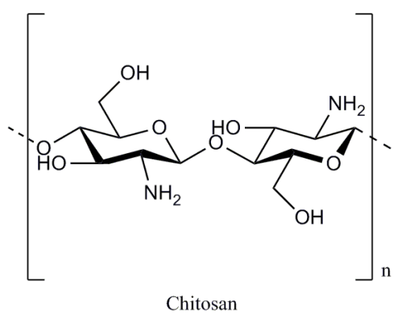

*Figure 1. Chemical structure of chitosan (Hao et al., 2017)*

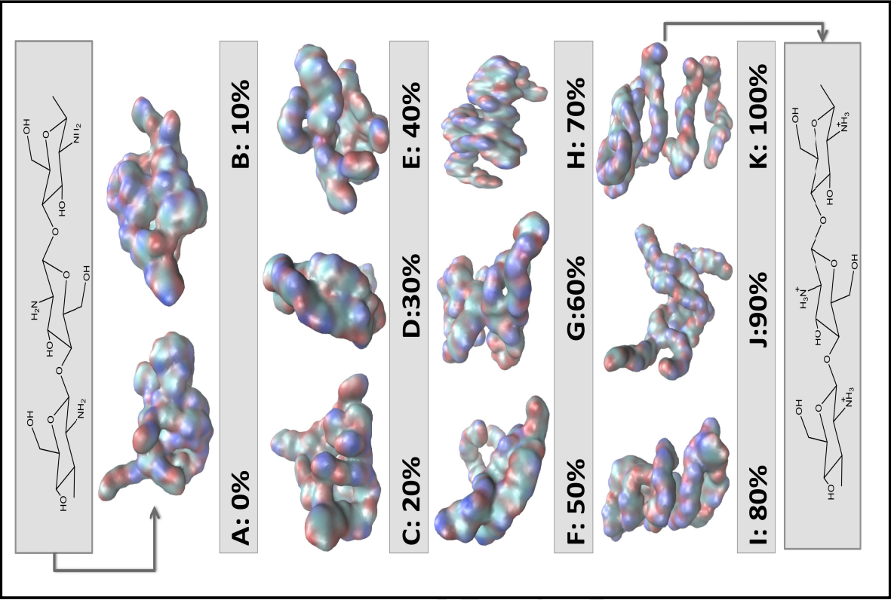

*Figure 2. Conformation of chitosan at different protonation levels, 0-100%. (Dey et al., 2016)*

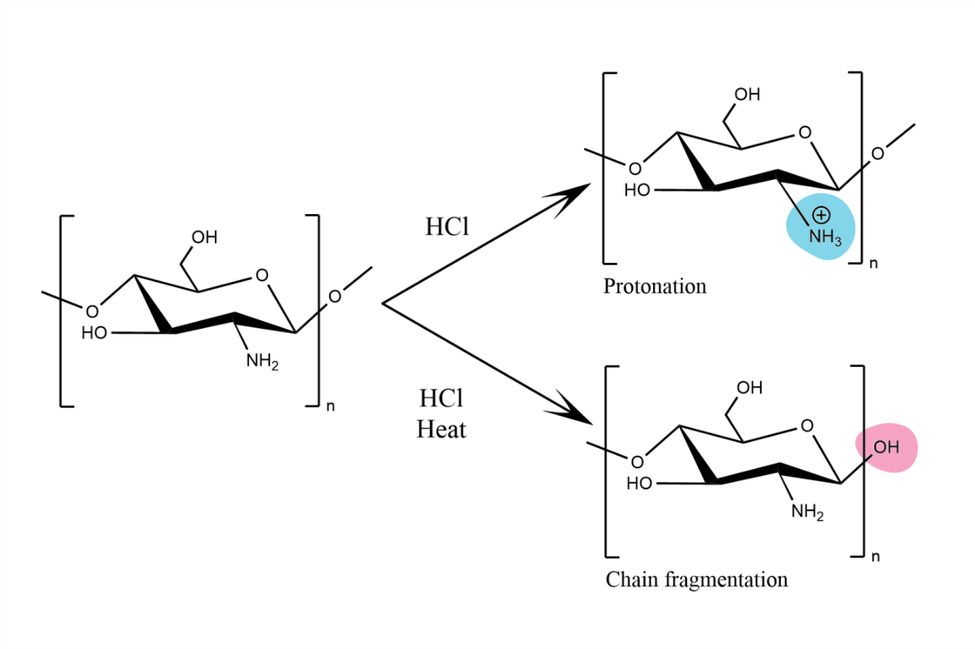  
*Figure 3. Reaction of chitosan with HCl is temperature dependent*

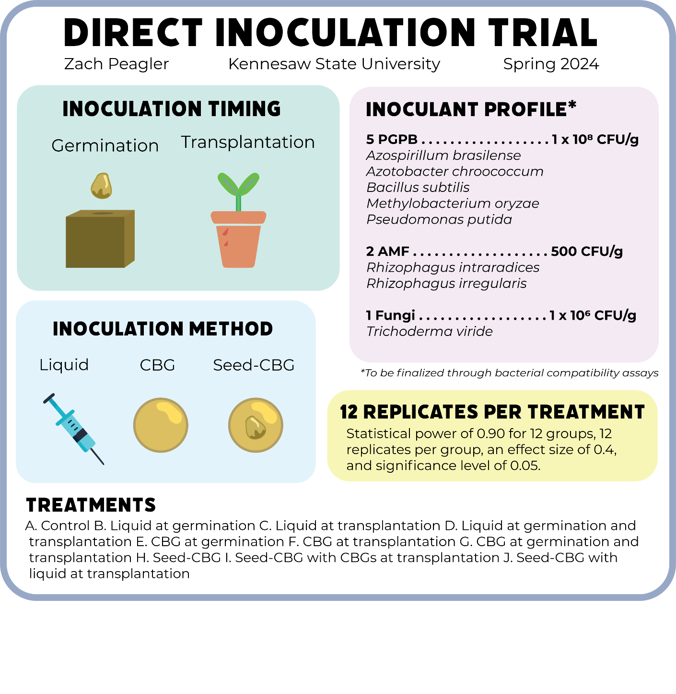

*Figure 4. Graphical abstract of Spring 2024 direct inoculation trial*

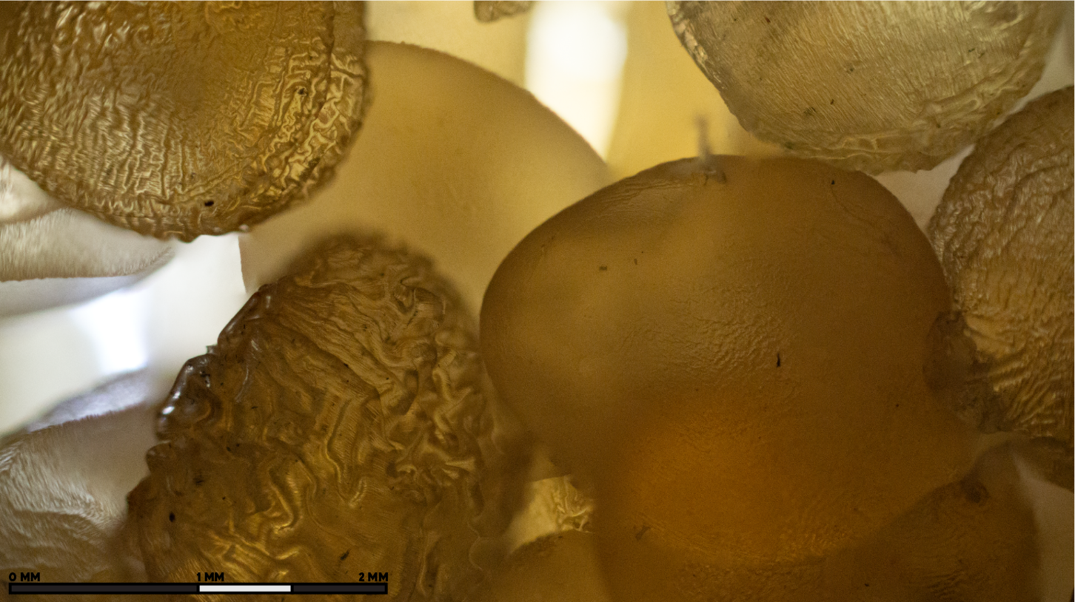*Figure 5. Examples of variety in bead morphology created under the same conditions*

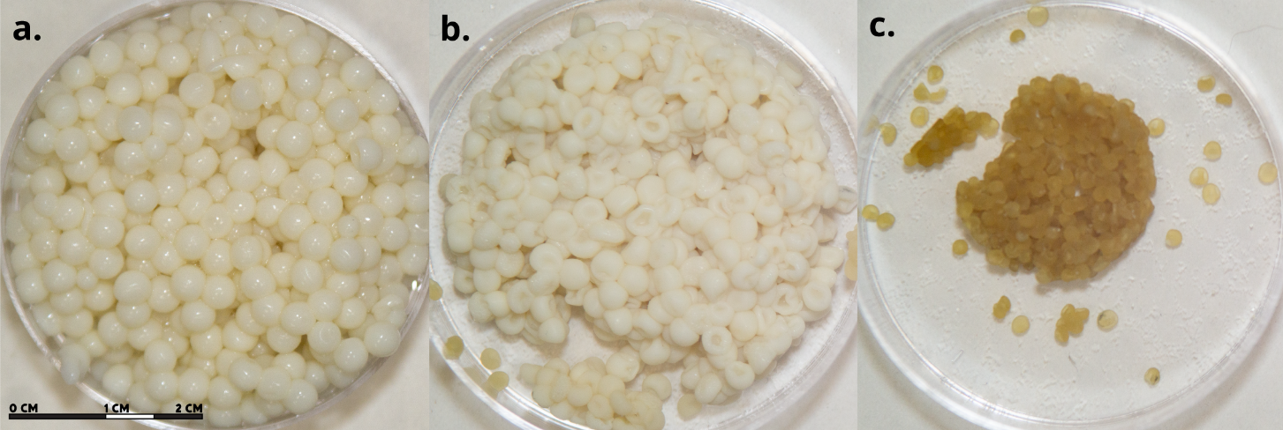*Figure 6. Chitosan beads a. non-desiccated, b. desiccated for three days, c. desiccated for ten days, created through dropwise addition and air dried*

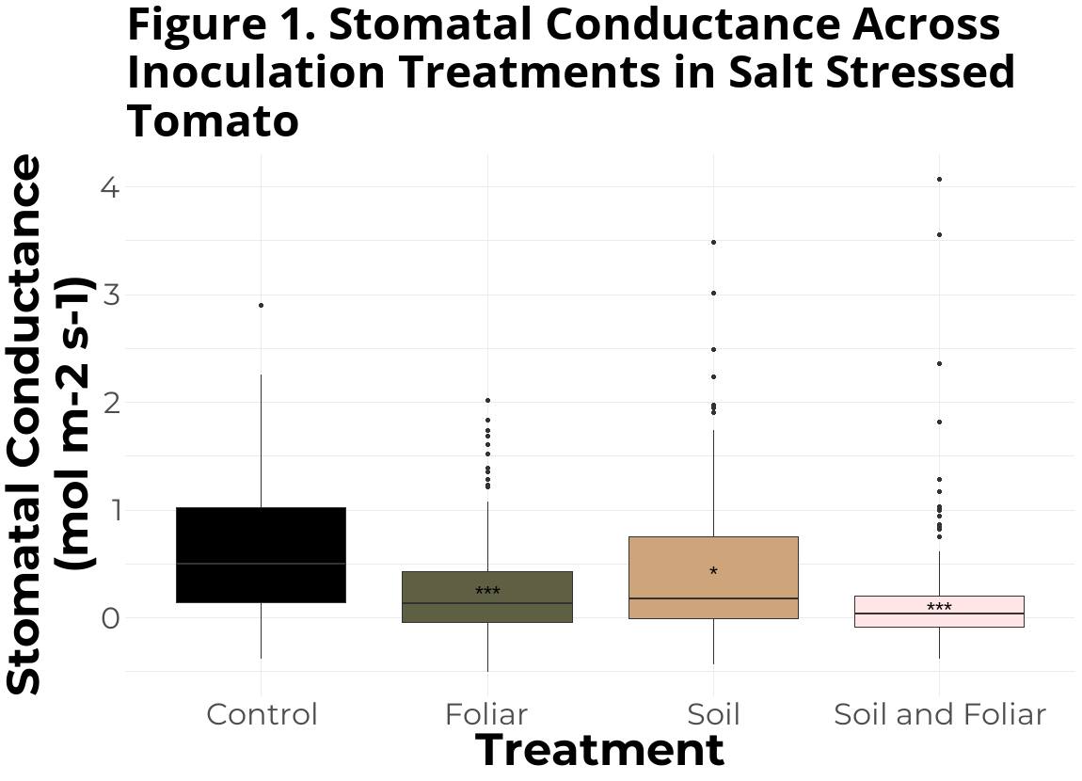

*Figure 7. Stomatal conductance (mol m-2 s-1) across inoculation treatments of salt stressed tomato*

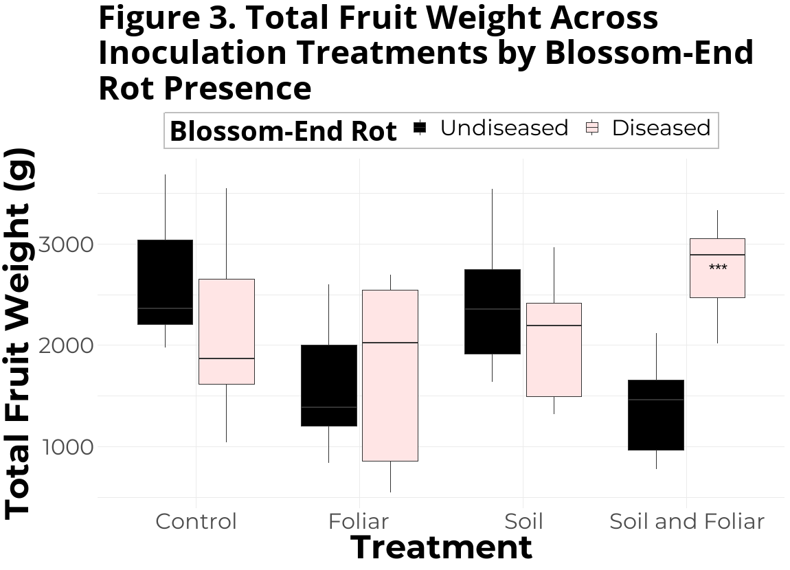

*Figure 8. Total fruit weight (g) by blossom-end rot presence across inoculation treatments of salt stressed tomato*

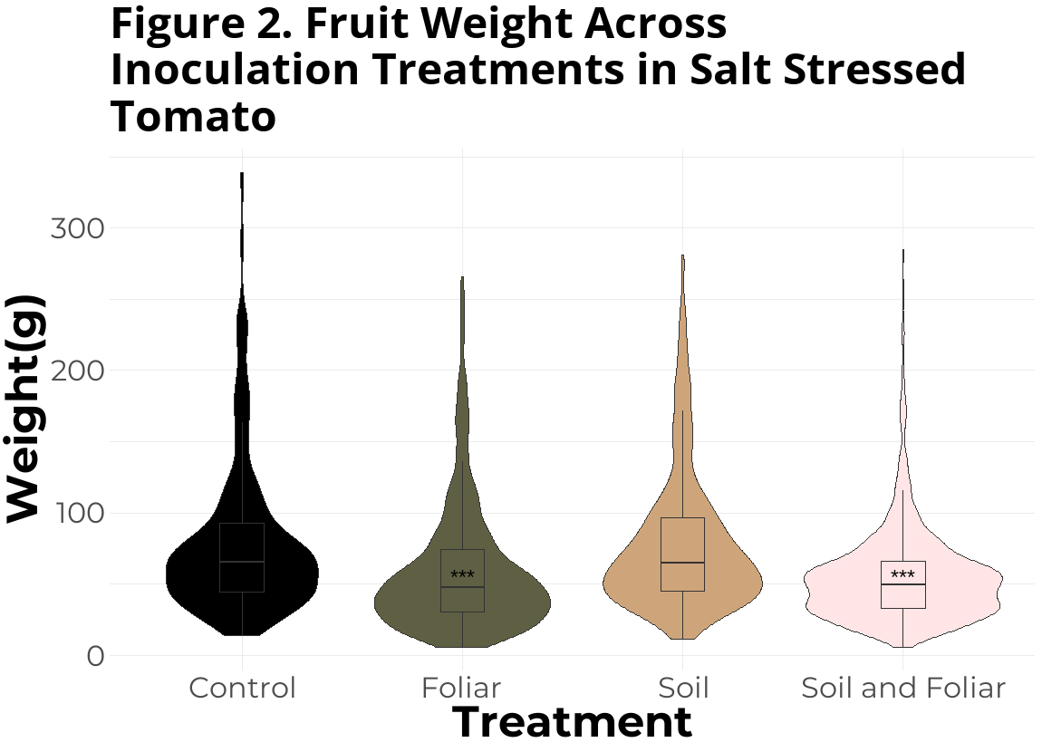

*Figure 9. Fruit weight (g) across inoculation treatments of salt stressed tomato*

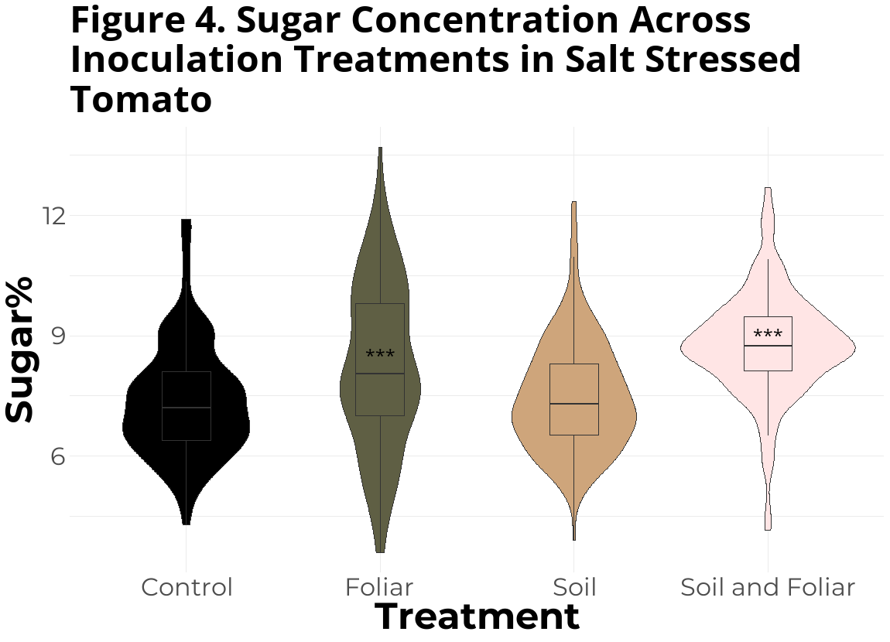

*Figure 10. Sugar concentration (%) across inoculation treatments of salt stressed tomato*

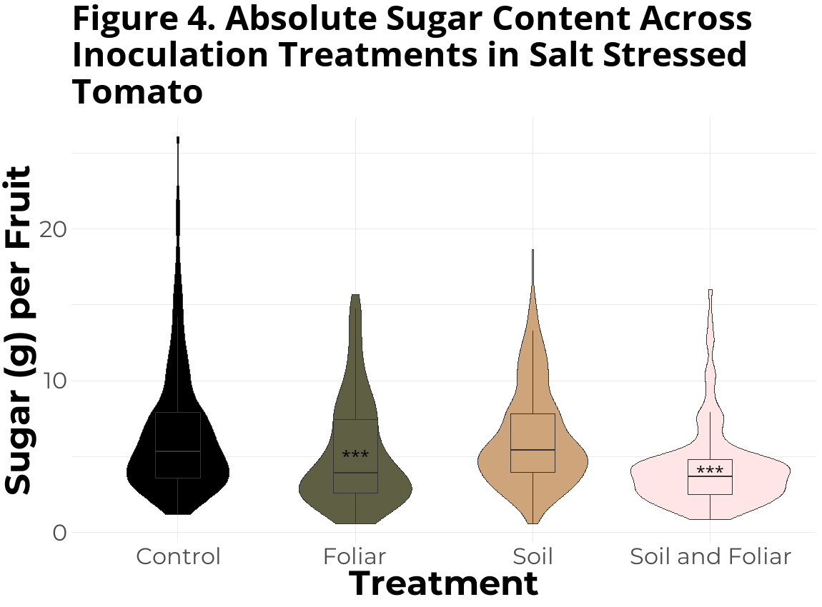

*Figure 11. Sugar per fruit (g) across inoculation treatments of salt stressed tomato*